|  |  |
| --- | --- |
| F:\NAAC\LOGO_60005.jpg | **IDEAL COLLEGE OF ARTS AND SCIENCES (A)** |
| *(A.P. Govt., Aided., Autonomous & NAAC B++)* |
| Dr. P.V.N. RAJU VIDYAPRANGANAM |
| Samalkot Road, KAKINADA  East Godavari Dist  Andhra Pradesh |

Department of Chemistry

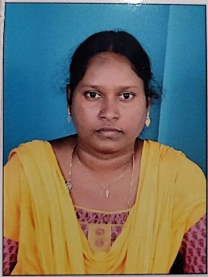

Profile

1. **Name** : YALLA DEVI
2. **Designation and Place of work** : Lecturer in Chemistry

Ideal College of Arts & Sciences (A)

Kakinada-533003

A.P., INDIA.

1. **Date of Birth** : 03-09-1990
2. **Nationality** : Indian
3. **Mobile no** : 9553267198
4. **E-mail** : [lovadevi90@gmail.com](mailto:lovadevi90@gmail.com)
5. **Address for Correspondence :**  YALLA DEVI

Lecturer in Chemistry

Ideal College of Arts & Sciences,

Kakinada – 533 003, A.P., India.

1. **Details of Educational Qualifications:**

|  |  |  |  |  |
| --- | --- | --- | --- | --- |
| **Sl. No** | **Course** | **University** | **Year** | **Specialization** |
| 1. | M.Sc | Adikavi Nannaya University, Rajamahendravaram | 2020 | Organic Chemistry |

1. **Experience:**

|  |  |  |  |  |
| --- | --- | --- | --- | --- |
| **Sl. No** | **Designation** | **College** | **Date of Joining** | **Experience** |
| 1 | Assistant Professor | Ideal college of Arts & Sciences, Kakinada | 05-02-2024 | 3 Years |

1. **Administrative Experience:** 
   1. Member in Admission committee
2. **Regional/ State/National and International level Conferences/Workshops/Seminars**
   1. Attended **“RUSA Sponsored One day National Seminar on INTER DISCIPLINARY ASPECTS OF ENVIRONMENTAL SCIENCE”** held at Dr. Sarvepalli Radha Krishna Govt. Arts College, Yanam.
   2. Attended **“Two Day National workshop on Radio Chemistry & Applications of Radioisotopes”** held at P.R Govt (A), Kakinada.
   3. Attended **“One Day State Level Seminar on Recent Trends in Material Science”** held at Ideal College of Arts & Sciences, Kakinada.
   4. Third Annual International Conferrence (AIC-3) Industry-CCRS Congress (ICC) 2015 held at B.R. Ambedkar University, Srikakulam, Andhra Pradesh on December 16 &17 th 2015 Presented a paper **“ Eco Friendly Technologies & Green Chemistry”**

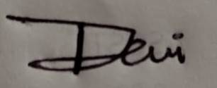

YALLA DEVI

Assistant Professor

Department of Chemistry